Tour de Dane Femmes 2025

Welcome to the fourth year of the annual Tour de Dane Femmes. We are excited to introduce a new format to increase participation and generate enthusiasm for women’s cycling.

Here are the rules of engagement:
- The Tour consists of 8 stages
  - Stages can be completed any time between Aug 1st through 31st, 2025
  - Stages can be logged in any order
  - All stages must be completed to be eligible for prizes
  - Only 4 stages keep track of time: 2 mountain stages for polka dot points, 2 sprint stages for green points
  - All stages have community service to earn pink points

- There will be 4 awards. To be eligible for a podium award, the rider MUST complete all 8 stages.
Yellow General Category
    - Most miles accumulated during the month of August, including stages
    - You can lengthen any stage, so long as it includes the actual stage
    - Road, mountain and gravel miles all count!
    - IF YOU WANT TO BE A PODIUM CONTENDER, PLEASE KEEP A LOG OF YOUR MILES FOR EACH DAY, AND NOTE TYPE (road or MTB). I can verify on Strava, but it would be helpful if you could submit a file and do the math for me. In this file, please include any supporting documents (receipt for Rails to Trails donation, CORP membership, promissory note to volunteer at HHH). Please email one completed document to me upon completion of the tour. Thanks.

Green Points Classification
    - Rider who earns the most points during the Mountain Stages (3 & 4)
    - 5 points for first, 4 points for second, 3 points for third and 1 point for finishing
    - In the event of a tie, we will stage a two lap criterium race for a face off.

Polka Dots Points Classification
    - Rider who earns the most points during the Mountain Stages (6 & 8)
    - 5 points for first, 4 points for second, 3 points for third and 1 point for finishing
    - In the event of a tie, the rider with the most MTB miles will win the polka dot prize. Incentive to get dirty. Please keep track of your MTB miles!

Pink Points Classification for Spirit of the Sport
    - All 9 stages have pink points available
    - 45 total points possible
    - In the event of a tie, the rider who has done the most events this calendar year will win the pink prize.
- Each completed stage must be submitted on Strava with the specified photo(s)
  - Be sure you request to join BrickO’s Drafters on Strava
  - Each stage needs to be labeled, “Tour de Dane Femmes Stage X”
  - You must be wearing an official Drafter Hincapie jersey in the photo
  - Please also text the photo to BrickO- I can’t always download them from Strava
________________________________________________________

TdDF Stage 1 No Gas
Go one full day without using your car. Every place you need to go will be by bike. Commute to work, run errands. Keep your Garmin running and submit one file. Honor system: if you drive ANYWHERE, no pink points, but you can count the miles towards the GC yellow prize.
Photo: you at one destination on your commute.
5 pink points
______________________________________________________________________________

TdDF Stage 2 LBS Love
Local bike shops keep us rolling. Let’s show them some love with random acts of kindness. Ride your bike to as many shops as possible, delivering goodies of alcoholic or non-alcoholic nature (see contacts below). There are no points for time, only miles counting towards GC.
Here is a route RidewithGPS link Stage 2 LBS Love with 5 stops.
Photo: you with contact person and verification of beer = 2 points each
10 pink points possible
Nothing to do at Motorless Motion and Cargo Bikes, just thought it was fun to include them on the LBS tour.
- Neff Cycles: beer for Kevin, Isaac or Paul (closed Mon)
- Cronometro: beer for Colin, Andrew and Andy (closed Sun-Mon)
- Machinery Row: beer for Slim
- Revolutionary Cycles: beers for Jeff (closed Sun)
- Slow Roll Cycles: beer for Dan and Stacy (closed Sun)

______________________________________________________________________________

TdDF Stage 3 Cross Plains Time Trial
Crossroads Coﬀeehouse has been a huge supporter of the Drafters. Let’s give back!
Order coﬀee, espresso, pastry or whatever looks good at Crossroads Coﬀeehouse.
Photo: you in Crossroads with your purchase.
5 pink points

The RidewithGPS link Stage 3 Cross Plains TT starts at the coﬀee shop. The TT timed segment won’t start until Bourbon Rd and KP so you can warm up a bit as you meander down Bourbon St. Camille has created a Strava segment, so go hard from as soon as you hit KP! This TT is a 12.2 miles, starting at Bourbon and KP, racing into Black Earth. Just before 78, you will ride a counter clockwise box: right on Easy St, left on Hubbell, left on Center, left back onto KP. Just before you reach Bourbon, you will need to complete the hilly lollypop, turning right onto Gils Way, and exiting on Tilda Trail back onto KP.

Green Points Classification: 5 points for first, 4 points for second, 3 points for third and 1 point for all other participants.
______________________________________________________________________________

TdD Femmes Stage 4 Stagecoach Sprint
The Creekside Scoop has hosted the Draft once a month, opening up their doors to us even before they were open to the public. Time to give back!
Photo: you in Creekside with your purchase.
5 pink points for enjoying an ice cream or pizza after your ride.

This is a short sprint stage for green jersey points with some serious climbing. The RidewithGPS link Stage 4 Stagecoach Sprint starts at Creekside Scoop and ends at the top of Stagecoach. The only timed portion for green points is the 0.45 mile sprint from P and Stagecoach to the top of the hill, which reaches a 16% grade! Camille has created a Strava segment for this sprint. You can make this ride as long as you’d like and count the miles towards the GC yellow prize.

Green Points Classification: 5points for first, 4 points for second, 3 points for third and 1 point for all other participants.
______________________________________________________________________________

TdD Femmes Stage 5 Gravel Grinder
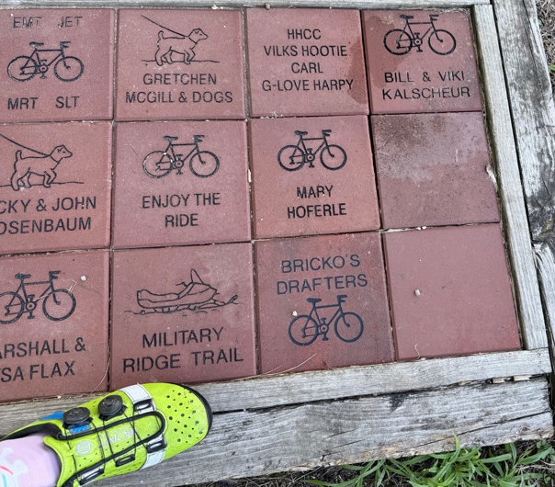
Although there isn’t a gravel stage in the Tour de France Femmes this year, we are going to have fun grinding some gravel.
Photo: Your foot (or face) and the BrickO’s Drafters brick located along the route (see location possibilities below).
5 pink points for supporting the Rails to Trails network by making becoming a member/making a donation OR becoming a Friend of Military Ridge. You can buy a brick to commemorate someone and have it placed at Verona, Mt Horeb, Riley Tavern, Ridgeway or Dodgeville. Submit proof of donation via email at the end of the tour along with your total miles.

RidewithGPS link Stage 5 Military Ridge Gravel Grinder starts at Riley Tavern and takes you to Blue Mounds and back (23 miles). Start in Verona and go to Governor Dodge State Park if you want a few more miles. There are no points for time, only miles counting towards GC.

______________________________________________________________________________

TdD Stage 6 Horribly Hilly
This half century mountain stage starts and ends in Cross Plains. There are no segments, only total time. If you stop, keep your Garmin running (be sure to have elapsed time setting on).
RidewithGPS link Stage 6 Horribly Hilly

Polka Dot Points Classification: 5 points for first, 4 points for second, 3 points for third and 1 point for climbing the HHH.

Photo: Since this is a timed loop, I won’t have you stop along the way. Snap a sweaty photo at the end in your Drafter jersey!
5 pink points if you promise to volunteer in 2026 for the climbing clinic (usually a Sat in April) and packet pick up (Thur June 18). In exchange, you will receive a free entry for the HHH on June 20th. Please write in blood and submit via email at the end of the tour along with your total miles.
______________________________________________________________________________

TdD Stage 7 Mountain Momma
What better way to honor a mountain stage than to ride a mountain bike! This stage is an opportunity to explore and enjoy diﬀerent terrain. If you are new to MTBing, please seek out the easier trails in our local CORP trails (green loop at Quarry Ridge and most of Seminole). There are no points for time, only miles counting towards GC.
Photo: you and your trusty steed with the trailhead sign.
5 pink points for being a CORP member or volunteering to help with trail maintenance. Submit proof of membership or weed whacking activity via email at the end of the tour along with your total miles.
______________________________________________________________________________

TdD Femmes Stage 8 Alp d’ Blue
The last stage of the Tour end with a push for the polka dot jersey points. This 30.8 mile route starts and finished at Blue Mound State Park. A state park pass is required.
There are 3 segments on this route.

Polka Dot Points Classification: Each climb segment: 5 points for first, 4 points for second, 3 points for third and 1 point for climbing.
Photos: One at the top of Blue Mound State Park (for polka dot points) and the other handing Zach a beer (for pink points).

5 pink points to stop in Blue Mounds Bicycle Works and bring Zach a beer. Be sure to check hours!

